PHYS 104 Lab 10 OPTICS 2

Introduction

In this lab you will study refraction and total internal reflection of light. You will use an **Optical Bench**, a **Ray Table**, and a **Cylindrical Lens**. You will tabulate your results using **Excel**.

Theory

*Refraction*

When light passes from one medium into another, its path is *refracted* or bent. That is why a pencil inserted in a water container appears to be bent. This phenomenon results from the fact that light travels at different *speeds* in different media. Let us define the **index of refraction** *n* of a given medium as the ratio between the *speed* of light in vacuum *c*, and the *speed* of light in this particular medium, *v*, i.e.

. (1)

**Snell's law** relates the *angle of incidence* *θ*1 and the *angle of refraction* *θ* 2 (i.e. the *angles* the *incident* and *refracted* light makes with the *normal* (see figure 1)) to the ratio of the *refractive indexes* of the two media *n*1 and *n*2in the following way

 ***Law of refraction (Snell’s Law)*** (2)

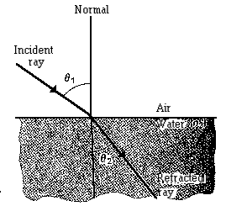

***n*1**

***n*2**

**Figure 1. Refraction of a ray.**

From **Snell’s Law**, it follows that if light travels from a medium with lower *index of refraction* into a medium with higher *index of refraction*, the light is bent towards the *normal* and the *refracted angle* is smaller than the *incident angle*. If, on the other hand, light travels from a medium with higher *index of refraction* into a medium with lower *index of refraction*, the light is bent away from the *normal* and the *refracted angle* is greater than the *incident angle*. Under those conditions for some *angle of incidence*, called the *critical angle* (*θ*c), the *refracted* ray will emerge along the interface between the media i.e. the refracted angle becomes 90° (see ray B infigure 2). At any *angle of incidence* greater than *θ*c, the light will be ***totally internally reflected***.

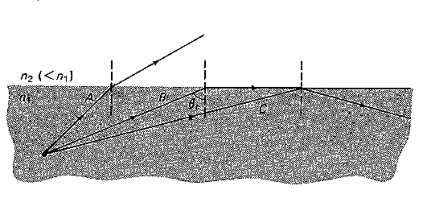

**Figure 2. Critical angle:** **ray A strikes the interface at an *angle* less than *critical angle*; ray B strikes the interface at the *critical angle*; ray C strikes at greater than *critical angle* and is therefore *totally internally reflected*.**

***n*2**

***n*1**

***n*1 < *n*2**

We can find the *critical angle* *θ*c, from **Snell's Law**:

 (3)

since the *incident* ray now travels through the medium with higher *refractive index* *n*2. The sin 90° is equal to1, and so we obtain

 (4)

If the medium of lower *index of refraction* is air (which index of refraction is 1) then

. (5)

Procedure

Part 1. Refraction

1. Set up the equipment as shown in figure 3.

Figure 7: Rotating Table and Angle Measurements

1. Adjust the light source so a single *ray* of light is aligned with the bold arrow labeled "*Normal*" on the **Ray Table**.
2. Carefully align the flat surface of the **Cylindrical lens** with the bold line labeled "Component" on the Ray Table. With the **lens** properly aligned and centered, the radial lines extending from the center of the **Degree Scale** will all be perpendicular to the circular surface of the **lens**.

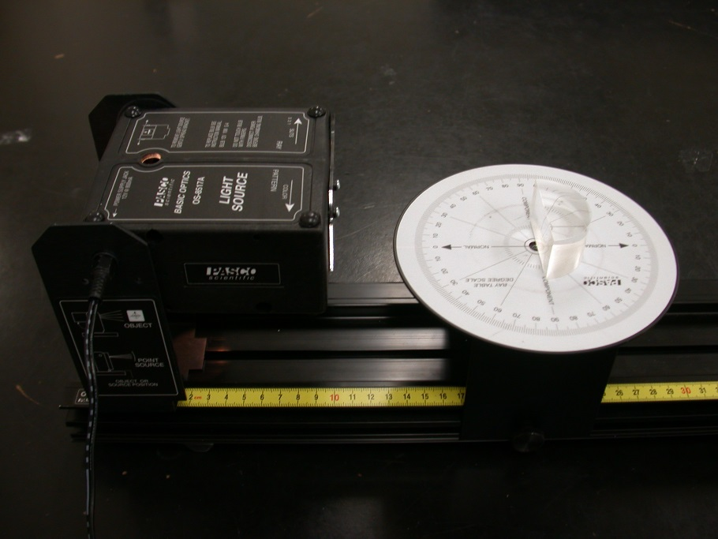

**Figure 3. Refraction setup.**

1. Without disturbing the alignment of the **lens**, rotate the **Ray Table** and observe the *refracted* ray for various *angles of incidence*.
   1. Is all the light of the ray *refracted*? Is some light *reflected*?
   2. Is there a *reflected* ray for all *angles of incidence*?
2. By rotating the **ray table*,*** set the *angle of incidence* to each of the settings shown in Table 1 below. The *angles of incidence* and *reflection* are measured with respect to the *Normal* to the *refracting* surface. For each *angle of incidence*, measure the *angle of refraction* (Refraction A). Repeat the measurement with the incident ray striking from the opposite side of the *Normal* (Refraction B) and average.

**Remember angle of incidence starts from the normal of the plane.

### Table 1. Refraction

|  |  |  |  |  |  |
| --- | --- | --- | --- | --- | --- |
| θ1 | θ2 A | θ2 B | Angle Difference between θ2 A andθ2 B | Average θ2 | *n 2* |
| **30°** |  |  |  |  |  |
| **40°** |  |  |  |  |  |
| **50°** |  |  |  |  |  |
| **60°** |  |  |  |  |  |

1. Are your results for the two sets of measurements the same? Should they be?

Assume that the index of refraction for air is equal to 1 in order to find *n 2*.

Part 2 Total internal reflection

1. Set up the equipment as shown in figure 4. Rotate the **Ray Table** and the by 180° so that the circular surface of the **Cylindrical lens** faces the light source.

Figure 7: Rotating Table and Angle Measurements

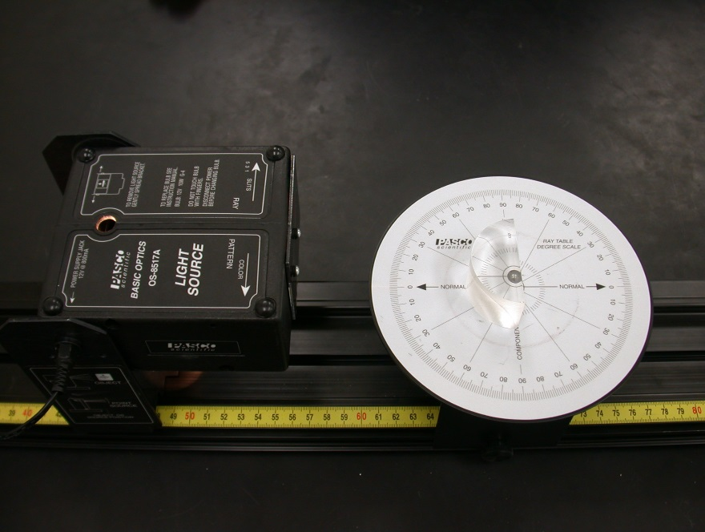

Figure 4. Total internal reflection setup.

1. As in **part 1** make sure that the light ray enters the center of the cylindrical lens. Check that the ray is only bent when it passes out of the lens through its flat surface.
2. Observe and answer the questions below.
3. Is all the light of the ray *refracted*? Is some light *reflected*?
4. Is there a *reflected* ray for all *angles of incidence*?
5. How do the intensities of the *reflected* and *refracted* rays vary with the *angle of incidence*?
6. At what *angles* is all the light *reflected* (i.e. *total internal reflection* occurs)?
7. Measure the *critical angle* and use equation (5) to determine the *index of refraction* of the acrylic. How does this value compare with the average value of the *index of refraction* calculated in **part 1.5**?

**lab 10 Report** Name……………………………...

Name……………………………...

Name……………………………...

Data Presentation:

Part 1. Refraction

4.a)

b)

5.

|  |  |  |  |  |  |
| --- | --- | --- | --- | --- | --- |
| θ1 | θ2 A | θ2 B | Angle Difference between θ2 A andθ2 B | Average θ2 | *n 2* |
| **30°** |  |  |  |  |  |
| **40°** |  |  |  |  |  |
| **50°** |  |  |  |  |  |
| **60°** |  |  |  |  |  |

6.

Part 4 Total internal reflection

3. a)

b)

c)

4.

5.

**REMINDERS:** Include units.

Make sure to attach all your data and graphs. No data = No credit

Please do not hand in the manual, just the report.